I want to do a data window.

When I selected a field date type.
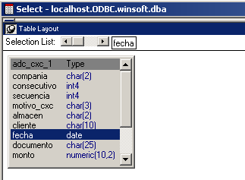

In datawindow painter show char(10).

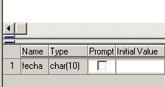

How to keep the same type of field in a DataWindow Painter?

